Meet The Ta!

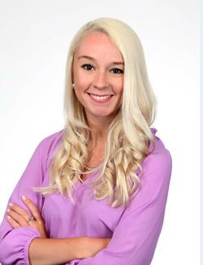
The Basics!

Hi! My name is Ms. Sydney Baysden! I am going to be Ms. Dodson’s TA for the remainder of the 2015-2016 school year. This is my first year as a TA after working in real estate for a few years and I am so excited to be here at Alston Ridge! I am already having a blast!
https://mail.google.com/mail/u/0/?ui=2&ik=a63edbb394&view=fimg&th=14e51e1b494dd24a&attid=0.1&disp=inline&safe=1&attbid=ANGjdJ9ssHY22Jzk2_GRtZ6QH5MGQ5TsRfoJwmGLvcFkPgp_Top5E6PCYg7gA4ADFQhC9d3hI233E6KVL0TyvFRZR3ItoH7lKu30uncsxCJKpsW6d2Dy9jjAN880R_Q&ats=1435893176550&rm=14e51e1b494dd24a&zw&sz=w1342-h515
In December 2015 I graduated with a Bachelor of Arts in Political Science from NCSU. I am currently pursuing my Master’s in Elementary Education there as it has always been a dream of mine to work at an elementary school!
I grew up in Apex, NC and have been a part of WCPSS for a majority of my life. I was on the year round schedule from Kindergarten to 8th Grade. I am the oldest of 4 siblings who also all attended schools in the area.
Contact me!

Email : sbaysden@wcpss.net
Class Webpage : http://msdodsonare.weebly.com
School Phone Number : (919) 544-2474
You can also write a note in your student’s folder!
My Childhood!

My Education!

My Favorites!

Birthday : March 7th
Color: blue
Sports Team : NC State Wolfpack or Carolina Panthers
Candy : anything sour or chocolate!
Drinks : Mountain Dew
Restaurants : Outback or Bojangles
Stores : Loft and Target
Hobbies : playing with my two cats and going shopping!

