Quarter 4: Common Core Standards

These are the standards we will be assessing this quarter.

**Reading: Key Ideas & Details**

**Fiction**

*RLK.3 **-** With prompting and support, identify characters, settings, and major events in a story.

*RLK.4 – Ask and answer questions about unknown words in a text

RLK.5 **-** Recognize common types of texts (e.g., fiction, nonfiction, poems).

**\*RLK.9 -** With prompting and support, compare/contrast the experiences of characters in familiar stories.

**Nonfiction** 

*RIK.3 **-** Describe the connection between two individuals, events, ideas, or pieces of information in a text.

*RIK.4- Ask and answer questions about unknown words in a text.

*RIK.7 – Describe the relationship between illustrations and the text in which they appear (e.g., what person, place, thing, or idea in the text and illustration depicts).

*RIK.8 – Identify the reasons an author gives to support points in a text.

*RIK.9 –Identify basic similarities in and differences between two texts on the same topic (e.g., in illustrations, descriptions, or procedures).

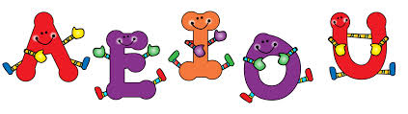

**Reading: Foundational Skills**

RFK.2b **-** Demonstrate understanding of spoken words, syllables, and sounds (phonemes). Count, pronounce, blend, and segment syllables in spoken words.

**RFK.3b -** Know and apply grade-level phonics and word analysis skills in decoding words. Associate the long and short sounds with common spellings (graphemes) for the five major vowels.

**RFK.3c -** Know and apply grade-level phonics and word analysis skills in decoding words**.** Read common high frequency words by sight (e.g., *the, of, to, you, she, my, is, are, do, does*).

**RFK.3d -** Distinguish between similarly spelled words by identifying the sounds of the letters that differ.

**Writing**

*WK.1 -Compose opinion pieces in which they tell a reader the topic they are writing about and state an opinion or preference about the topic (e.g., *My favorite book is… because….). This standard also encompasses persuasive writing; students will state a topic sentence and add reasons to support their opinion.*

**\*WK.3 - Narrate a single event or several loosely linked events, tell about the events in the order in which they occurred, and provide a reaction to what happened.**

*WK.6 **-** Explore a variety of digital tools to produce and publish writing, including in collaboration with peers.

WK.7 – Participate in shared research and writing projects

**Speaking & Listening**

SLK.3**-** Ask and answer questions in order to seek help, get information, or clarify something.

SLK.4**-** Describe familiar people, places, things, and events and provide additional details.

SLK.6- Speak audibly and express thoughts, feelings, and ideas clearly.

**Language**

**LK.2a -** Demonstrate command of the conventions of Standard English capitalization, punctuation, and spelling when writing.

**LK.2d-** Spell simple words phonetically, drawing on knowledge of sound-letter relationships.

LK.5d - Explore word relationships and nuances in word meanings. Distinguish shades of meaning among verbs.

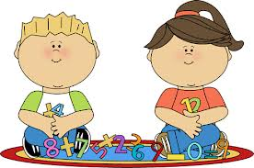

**Math: Counting & Cardinality**

**K.CC.1** Count to 100 by ones and tens. (Q4: Rote count to 100; count by 10’s to 100)

**K.CC.2** Count on from a given number (instead of having to begin back at 1)

**K.CC.7** Compare 2 numbers between 1-10 presented as written numerals.

**Operations & Algebraic Thinking**



**K.OA.1** Represent addition and subtraction with objects, fingers, mental images, drawings, sounds,

verbal explanations, expressions, or equations.

**K.OA.2** Solve addition and subtraction word problems, add and subtract within 10 (using objects or

drawings to represent the problem).

**K.OA.3** Decompose numbers less than or equal to 10 into pairs in more than one way

(4=0+4, 4=1+3, 4=2+2, 4=3+1, 4=4+0)

**K.OA.4** For any number from 1-9, find the number that makes 10 when added to the given number.

**K.OA.5** Fluently add and subtract within 5. (Continued from Q3)

**Measurement & Data**

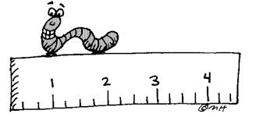

**K.MD.1** Describe measurable attributes of objects, such as length or weight. Describe several measurable attributes of a single object.

**K.MD.2** Directly compare two objects with a measurable attribute in common, to see which object has “more of”/“less of” the attribute, and describe the difference.

**K.MD.3** Classify objects into given categories; count the numbers of objects in each

category and sort categories by number.

***Social Studies (“What’s Around Me”):***Students use geographic representations and terms to describe surroundings. Students **understand** location, can **apply** locating places around them, are able to **analyze** map, and **apply** locating features on a map. Students can **evaluate** maps and show an **understanding** them by **creating** their own maps.

***Science (Weather):*** Understanding the elements of weather helps us to plan our daily lives. This unit uses the Guided Inquiry approach to teach content about the observable properties (characteristics) of weather and ways to communicate those observations to others. Students compare and contrast the properties of weather including types of weather, clouds and tools used in measuring weather.

***Science (Animals 2 x 2)****:* Living things and their habitats have characteristics that can be: observed, compared, and categorized. **Students will compare characteristics of animals that make them alike and different from other animals and nonliving things. Students can compare the characteristics of living and non-living things in terms of their structure, growth, changes, movement, and basic needs.**

***Please let me know if you have any questions regarding these standards.***

***Thank you for all of your continued support from home! ☺***